**JBL**

**Interface Requirement Document**

**SMS Service**

Table of Contents

Amendment History 3

DOCUMENT SIGNOFF 3

Keywords 3

Objective 4

Overview 4

Existing Functionalities 4

Proposed Functionalities 4

System Environment 5

Design Tools Requirement: 5

Testing Tools Requirement: 5

Business Requirement: 5

High-level Technical Design 6

API Documentation 6

Supporting Screenshots of existing functionality: 8

Assumptions & Dependencies: 8

DISCLAIMER 8

# Amendment History

| Version | Date | Author / Changed By | Change Description |
| --- | --- | --- | --- |
| 0.1 |  |  |  |
| 0.2 |  |  |  |
| 0.1 |  |  |  |

Comments:

|  |
| --- |
|  |
|  |

# DOCUMENT SIGNOFF

| Version | Date | Nazihar Authorization | JBL Authorization |
| --- | --- | --- | --- |
| 0.1 |  | -----------------------------------  Eleyes Md Adhil Buyan  Sr. Technical Consultant | -----------------------------------  Md Zakir Hossain  Principal Officer (PO) |
| 0.1 |  | -----------------------------------  Chowdhury Fakhruddin Mahmud Siddique  CTO & Technical Lead | -----------------------------------  K. M. Sharif Uddin  DGM-ICT & Assistant PM |
| 0.1 |  | -----------------------------------  A. B. M. Kalim Ullah  PM & Sr. Business Consultant | -----------------------------------  Md. Nurul Islam Mozumder  GM-ICT, Technical Lead & PM |

# KEYWORDS

| Keyword/Abbreviation | Description |
| --- | --- |
| JBL | Janata Bank Limited |
| API | Application Programming Interface |
| SMS | Short Message Service |
| CBS | Core Banking Software |
|  |  |

# Objective

The objective of this document is to specify the integration scope for SMS system with CBS–T24 through IRIS API framework.

# Overview

At present, Janata Bank provides transaction notification alerts to customers using bulk SMS. CBS communicates with SMS Server via several touch points with time-consuming traditional file sharing system. We have following requirements to be considered for IRIS API development:

* Transaction SMS Sending
* Bulk SMS Sending
* On-demand SMS Sending
* User Management/OTP

The above API will receive financial transaction notifications, balance confirmation, on-demand notification, etc. request from CBS-T24. The format of request and response has been defined later in this document.

# Existing Functionalities

Currently, CBS sends SMS using “SMS Center” which uses a complex file sharing system to communicate with CBS-T24.

# Proposed Functionalities

CBS-T24 will consume following API to send SMS. The request and response of the API support JSON format.

JBL send following types of SMS to customer:

* Transactional
* Non transactional
* User Management/OTP
* Bulk SMS Sending
* On-demand SMS Sending

Transactional, Non-transactional & User Management/OTP SMS:

1. During transaction SMS related information will be write in local template in CBS.
2. A backend service will build the SMS body based one SMS body parameter and SMS transactional data template. Then it will consume the SMS API and send request to SMS gateway system.
3. CBS may need to consume separate API based on SMS type

Bulk & On- Demand SMS:

1. SMS body text file will be put on a physical location of the server
2. A local template for SMS client selection condition. Basic selection condition will be configurable. But for complex criteria, a selection routine needs to be attached.
3. A backend service will read the SMS body from physical location. Then it will consume the SMS API and send request to SMS gateway system.

# System Environment

|  |  |
| --- | --- |
| Description | Version |
| Operating System | IBM UNIX |
| T24 Release | R22 |
| Database | 19C |
| Web Service | RESTful |
| Supported file format | JSON |

# Design Tools Requirement:

|  |  |
| --- | --- |
| Testing tools | Functionality |
| Design Studio | Used to design the RESTful API |

# Testing Tools Requirement:

|  |  |
| --- | --- |
| Testing tools | Functionality |
| Postman | Used to test the RESTful API |

# Business Requirement:

|  |  |  |
| --- | --- | --- |
| Serial | Title | Functionality |
| 1 | Transaction SMS Sending | Sends single SMS with specific priority. |
| 2 | Bulk SMS Sending | Sends multiple SMS with specific priority. |
| 3 | On-demand SMS Sending | Sends single SMS with custom priority. |
| 4 | User Management/OTP | Send single SMS with specific priority. |

# High-level Technical Design

Transactional, Non-transactional & User Management/OTP SMS:

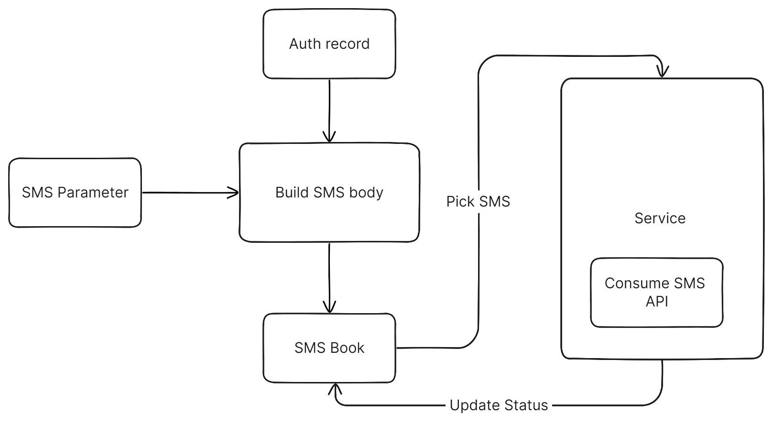

Bulk SMS:

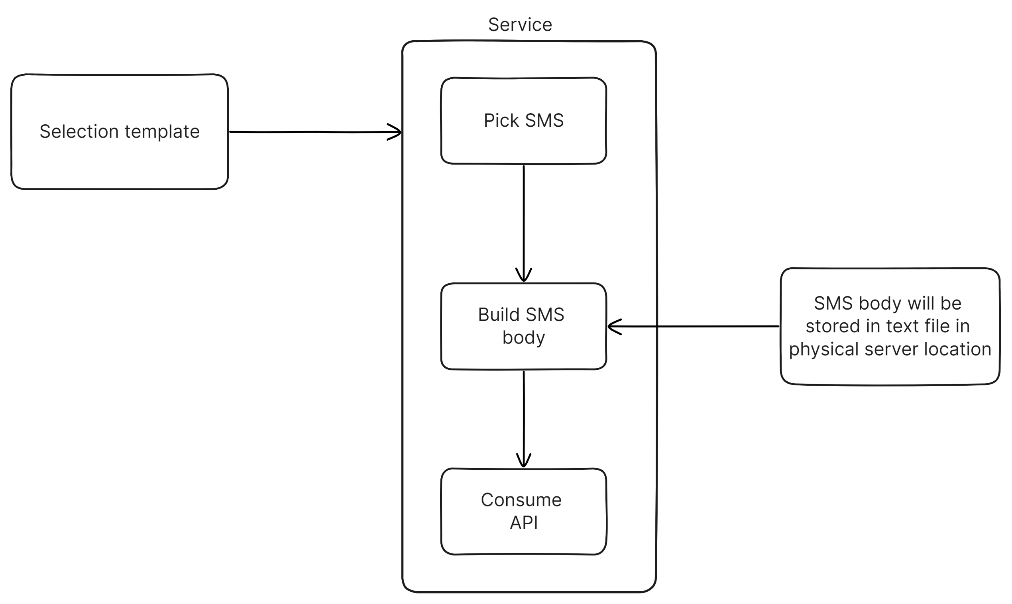

# API Documentation

**API Title:** JB SMS Center API.

**Descriptions/Requirements:** The purpose of the API is to send different type of SMS to customers registered mobile numbers. Also sending official SMS for management purpose. Bank will provide separate API for separate types of transaction.

**T24:** Consumer.

**T24 Components:**

**Pre-Requisites/Dependency:** SMS alert must be activated by the customer and mobile number must be captured in CUSTOMER table in 11-digit format.

**Restrictions & Exclusions:** Invalid mobile numbers. Foreign mobile numbers will be excluded also. **System considers only 11-digit number as valid mobile local number.**

**Accounting:** NA

**Request Parameter:**

**Field Details**

|  |  |  |  |
| --- | --- | --- | --- |
| SeqNo | Field Name | Required* | Possible Values/Characteristics |
| 1 | Recipient | Yes | Mobile number (11 digit) |
| 2 | Message | Yes | Existing R09 message |

Note: For foreign account number consume separate API

**Response Parameter:**

**Successful message format:**

Response will be received with HTTP Status Code 200 (OK). Json Response Sample:

{

    "SmsID": "fd89dfe0-8cd5-4f71-938c-ef2c29b7130c",

    "StatusCode": 1,

    "StatusText": "SUCCESS",

    "Message": **null**

}

**Failed message format:** If the api is working but validation error occurs, following response will be received.

{

    "SmsID": **null**,

    "StatusCode": -1,

    "StatusText": "Error",

    "Message": "Mobile number must be 11 digits"

}

**API Testing:**

|  |  |  |  |
| --- | --- | --- | --- |
| Serial | Scenario | Expected Result | Remarks |
| 1 | Valid mobile number and valid message. | SUCCESS |  |
| 2 | Invalid mobile number and valid message | ERROR, Invalid mobile number related error message. |  |
| 3 | Valid mobile number and invalid message. | ERROR, Invalid message related error message. |  |

# Supporting Screenshots of existing functionality:

# Assumptions & Dependencies:

1. CBS have a flag to active the SMS alert.
2. CBS will retry every unsuccessful SMS until successful.
3. For bulk SMS system performance may degrade considering the huge IO
4. It may take longer times to send the all SMS

# DISCLAIMER

The request and response parameter may be changed if both parties agreed.